25.36: a) The current is counterclockwise, because the 16 V battery determines the direction of current flow. Its magnitude is given by:
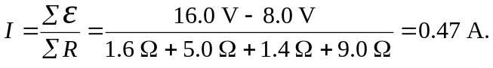
b)
c)
d)
